**Lecturer’s Name: Israil Kurbaniyazov**

**Report**

**Topic: Law and Crime**

**Title: What are the main reasons for divorce between young families in Uzbekistan today?**

**Word count**: **2036**

Executive Summary

Being aware about main reasons of divorce between young families is becoming popular and debatable topic among ordinary people and researches. This study illustrates one of the main reasons of divorce in Uzbekistan with the help of literature review regarding this topic. By taking survey among students who study at Westminster International University in Tashkent, all necessary information were collected and analyzed. Furthermore, study includes conclusion and recommendations regarding causes of divorce in Uzbekistan, differences between private research and literature review. By deep analyses, study shows that conflicts and scandals are main reasons of divorce among young couples. However, people should read whole article in order to understand importance of the chosen topic.

Table of Contents

Executive Summary 1

Introduction 2

Literature Review 3

Methodology 4

Results 4

Discussion 5

Conclusion 6

Recommendation 6

References 8

Appendices 9

Introduction

Increasing divorce rate is becoming one of the most essential and debatable topics among people across the world. A divorce is considered as legal action between two people who married together and want to terminate their relationship legally. According to statistics, divorce rate is increasing gradually between 1970 and 2008, from 2.6 to 5.5 for each 1000 married couples (Divorce Rates around the World, 2020). Total population of particular country should divide the amount of divorced people in order to get divorce rate. According to statistics in 2020, the lowest divorce rate in Qatar (0.4) and highest rate in Russia (4.7). When it comes to Uzbekistan, the rate is 1per 1000 people with almost 34 million of people(Divorce Rates By Country, 2020).Understanding the main causes of divorce, can help to reduce divorce rate across the world. This study investigates works of world-known researches regarding divorce and their contribution in this field. For example, Pinsof (2002) argued that most marriages end their relationship by the help of divorce or Finnas (2000) shared with idea that changes in husband or wife’s income can lead to termination of marriage. Lack of money or financial problems are also considered as main causes of divorce (Burgess, 1997). Wells provided interesting point in 2001; he argued that reducing living standards could lead to divorce between young couples. This study examines the main causes of divorce among young people in Uzbekistan. Paper contains background information, literature review, methodology, results and conclusion regarding divorce. The literature review will provide examples of studies and the results of scholars among young families. The methodology part will be about what method we decided to use in order to do a research, the location of the survey and the number of participants. Also, the methodology will inform why this particular method was chosen and what its advantages are. Results part will describe the answers and results of the questionnaire. Conclusion part will sum up all information that was mentioned during the report. In recommendations part will be provided some advices regarding results of questionnaire. As divorce is action that can lead to many negative consequences and one of the main aspects is negative effect on children and their future.

Literature Review

According to Pinsof (2002), there are several causes of end marriages among people, but in last half of twentieth century, divorce became as the main end point of marriages. From the history, death was considered as extremely main cause of stopping marriages, but was replaced by divorce action. People do not want continue their relationship as a family, when they face with some difficulties in their life. They tend to think that divorce is the key action, which help to overcome problems and start their life from clean paper. However, another study by Finnas (2000), gives information that if husband’s level of income increased, risk of divorce in that family decreased, whereas this trend was exactly opposite if wife’s income increased in Finland. When husband’s income increased, family become happier and try to reduce some misunderstandings between each other and all members of family believe that they can overcome any problems that they will face. However, in most cases when wife’s income increased, women started to dictate their rules, they becoming more active in problem solving process in the family. Women tend to feel confidence and they ignore husband’s advice and take responsibilities themselves. Living standards are also considered as main causes of divorce and reducing such standards can lead to increasing the number of divorce rate (Wells, 2001). When people live in not appropriate conditions, many problems occur and in most cases, it ends with divorce. People could not live under pressure of their closest persons and they tend to think that divorce process can help to overcome their problems and live better than previously. According to Burgess (1997), young Americans who terminated their marriages had economic problems and lack of money lead to divorce. In most families, financial problems are considered as a tragedy or unsolved problem, they do not believe that they can start to earn much money, but in first stage they seeks ways to become a person with good salary and be able to cover all expenses of their family. However, not all people capable overcome financial problems and after long discussions between each other, they decide to divorce.

As we informed earlier, consequences of divorce strongly relate to the children and their future. Booth (1999) did a research and analyzed negative relationship between parental divorce and children. In most cases , children under a big pressure because they should choose one of the parents and live separately from farther or mother. By examination, some main causes of divorce from secondary sources by qualified researchers and recognize various number effects of divorce between young families. However, literature review is not fully researched and needed to be investigated in the future.

Methodology

This section is purposed to cover the techniques used in the research, after presenting the members of the study and moral issues concerning the investigation. The questions of research will moreover be examined in this chapter.

To begin with, students of Westminster International University in Tashkent were surveyed. 51 students of CIFS were the sample group of the research. Quantitative data collection method was decided to be applied, so questionnaire was made. It was thought that using Google forms to spread and collect data would be appropriate since the topic is about divorce and people need privacy when answering this question. The topic is a little bit sensitive, so people may have refused to answer during interviews. On the other hand, spreading online questionnaire promised respondents 100% privacy and confidentiality of their personality. So, when analyzing collected data, it was realized that respondents were open-minded and shared everything they knew or were aware of. The information was gathered during the brief timeframe time of about two-three weeks.

Results

The discoveries of the research will be introduced in a succession of significance for the exploration, starting with the least urgent outcome.

Graph 1 show that 42.1% were male and 52.9% were female. Respondents were at the ages of 17 to 24, when it was asked whether they were married, not married or divorced, 15.7% of them said they were married, (see graph 2). Surprisingly, however, when the next question was aimed to know whether any of those 51 respondents knew divorced families, the majority of them said yes, 62% approximately, which means that indeed the number of divorces has increased (refer to graph 3). We wanted to know what is the approximate time and period of those divorces. If one has a look at the next pie chart, one can clearly see that divorce happens within a year after the wedding, almost 51% of students were witnesses of this case, almost 30% of them have experienced divorce within 3 years, while 9.4 % equal percent of time were seen after a month and after ten year (refer to graph 4).

Since the main aim of research was to find about the reasons of divorce, next question was made. The most common reasons of divorce, according to the chart 5, are frequent conflicts and scandals between husband and wife or family members and incompatibility of characters, 41.3% and 37.3% correspondingly. Other important reasons are a hasty marriage and a usual treason, about 12% and 7% respectively.

After having so much information about divorce, a sub-question came to. It was interested to know whether there are any steps that could be taken to eradicate divorce in our country. Interestingly, it maybe be eliminated if following measures are taken before marriage. According to the respondents, 33.3% recommend to get married when couples are emotionally and physically ready to build a family. Having some background information about the spouse before the marriage is advised by about 27.5% of students. Attending to pre-marriage counseling sessions, physical health and considering financial status of the future life partner can also be considered as substantial steps that could be implemented into real life to avoid an increased number divorces(refer to graph 6).

Discussion

If results are compared with the findings of previous studies, the current research proved that financial status may become one of the reasons of increased divorce rate. The same idea was concluded by Burgess et al., 1997 and Finnas 2000. However, any relation between age and marriage was not seen since respondents who were 18 were also married and happy about their marriage, so the current findings contradict the results of Wells, 2001.

The following research has meant a lot to the team since seeing people love each other first and then get divorced, leaving love stories and children, probably, behind is painful. Actions, like introducing schools, have to be taken by the authorities since the research findings have proven it. However, unfortunately, one cannot be 100% sure since the scope of the research was small. All in all, the survey has given real cases of divorce and solutions accepted by the public, which is indeed very significant.

The research findings carry important value since one can understand the main problems that cause early split up of happy families in Uzbekistan. Also, with the help of the research questions, feasible solutions to eliminate divorce rate in our country were found. Our study has only covered 51 students of WIUT, which is a small sample for this wide topic. More researches ought to be led in a wide scope of a domain by including substantially more members to the study so as to get an aftereffect of domain, which straightforwardly impacts to produce an end.

Conclusion

To summarize, nowadays divorce is one of the most important topics that cannot be kept silent. The purpose of our study was to find out the most common causes of divorce between young families in our country. By involving 51 students of WIUT to respond to the survey questions, finding answer to the research question and sub-question was possible. As it was mentioned before, the main reasons of increased divorce rate in Uzbekistan are lack of understanding, lack of preparation, misunderstandings and, of course, poor financial status. Several measures, like introducing pre-marriage schools, should be taken into account to eliminate the increased rate. The higher position authorities should think about this idea, prepare family psychologists and make a compulsory obligation of attending such schools before marriage. It is believed that by doing so, our government will be able to eradicate divorces. In conclusion, the results of the study play a crucial role in understanding why today's divorces among young families have become very common.

Recommendation

Taking into consideration the findings of the research, following recommendations are given. First of all, pre-marriage psychological and emotional counseling schools for young couples should be introduced.Pre-marriage counseling helps partners improve their ability to communicate and establish a strong, healthy relationship with your partner. This type of counseling can also help couples identify their weaknesses in relationships that can become serious problems during marriage.

This will help the youngsters understand each other much better and get prepared for pressures and stress that may occur during the marriage life. In order to make long and strong marriage, before the wedding you need to have a faithful, long and healthy relationship behind your back. If the marriage is spontaneous and not out of love, or if you marry at the request of your parents, then the chances of an early divorce will increase. Also, deeper research into this field involving students of different levels at WIUT and different family situations should be conducted.

**Reference List**

American Psychological Association. (2019). Marriage and Divorce. Available at: <https://www.apa.org/topics/divorce/> [Accessed 2 Mar. 2020].  
Berlin, G. (2004). The Effects of Marriage and Divorce on Families and Children. MDRC. Available at: <https://www.mdrc.org/publication/effects-marriage-and-divorce-families-and-children> [Accessed 2 Mar. Burgess, A. (1997).

Fatherhood Reclaimed: The Making of the Modern Father. 1st ed. Oxford, pp.782020].

Finnas, F. (2000). Economic factors and marital stability in Finland. 53, pp. 121−131.

Jalovaara, M. (2002). Socioeconomic Differentials in Divorce Risk by Duration of Marriage. [Demographic-research.org](http://demographic-research.org/). Available at: <https://www.demographic-research.org/volumes/vol7/16/7-16.pdf> [Accessed 2 Mar. 2020].

ICRW (2013). Solutions to end child marriage - ICRW | PASSION. PROOF. POWER. *ICRW | PASSION. PROOF. POWER.* Available from [https://www.icrw.org/publications/solutions-to-end-child-marriage-2/](https://www.icrw.org/publications/solutions-to-end-child-marriage-2/%20) [Accessed 5 April 2020].

Mayo Clinic Staff (2018). Premarital counseling. *www.mayoclinic.org*. Available from [https://www.mayoclinic.org/tests-procedures/premarital-counseling/about/pac-20394892](https://www.mayoclinic.org/tests-procedures/premarital-counseling/about/pac-20394892%20) [Accessed 5 April 2020].

Psychology Today. 2020. *Divorce Rates Around The World: A Love Story*. Available at: <https://www.psychologytoday.com/us/blog/living-single/201902/divorce-rates-around-the-world-love-story> [Accessed 6 April 2020].

World population review.com. 2020. *Divorce Rates By Country 2020*. Available at: <https://worldpopulationreview.com/countries/divorce-rates-by-country/> [Accessed 6 April 2020].

Appendices

Graph 1

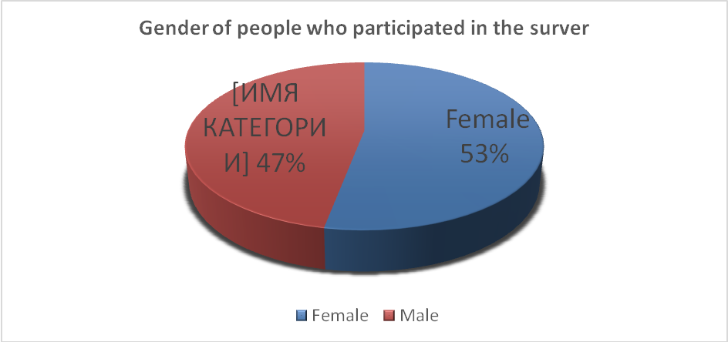

Graph 2

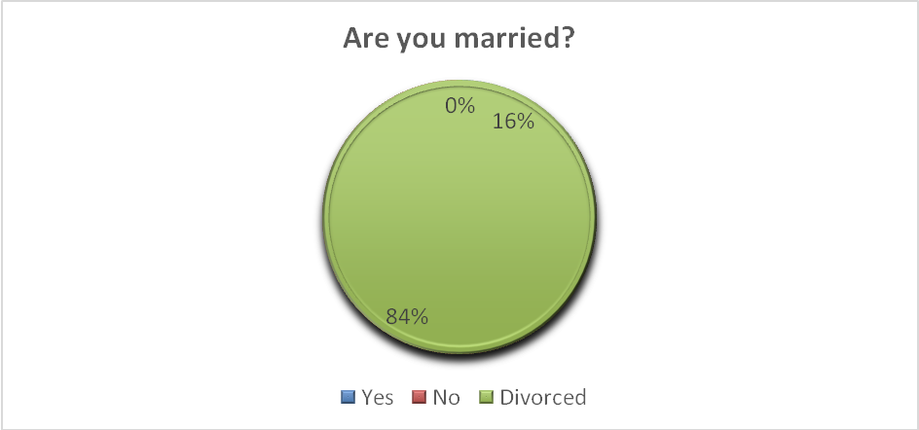

Graph 3

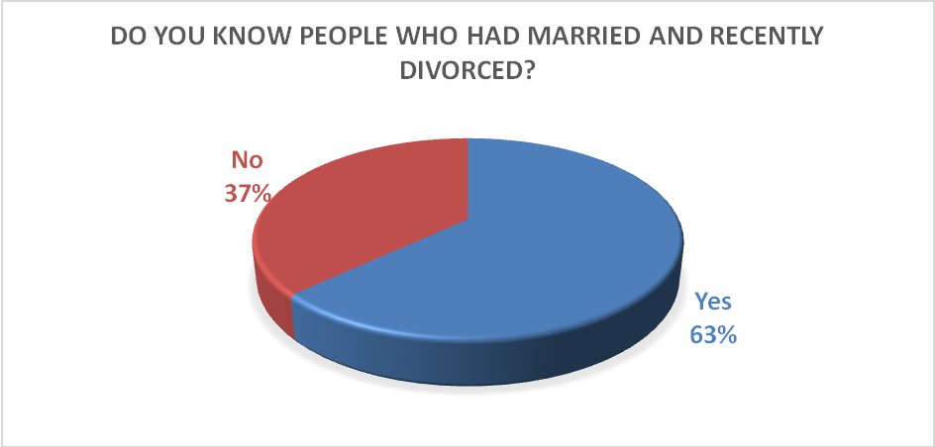

Graph 4

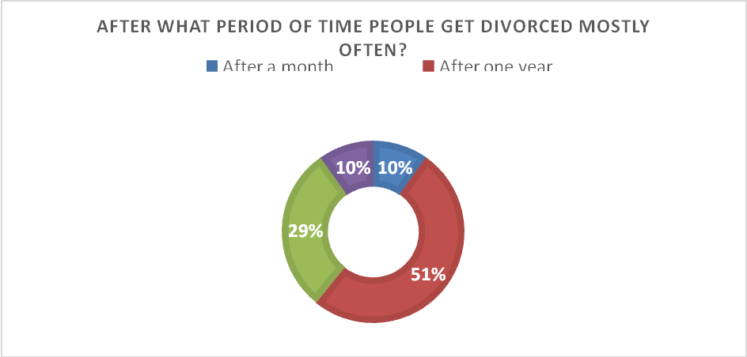

Graph 5

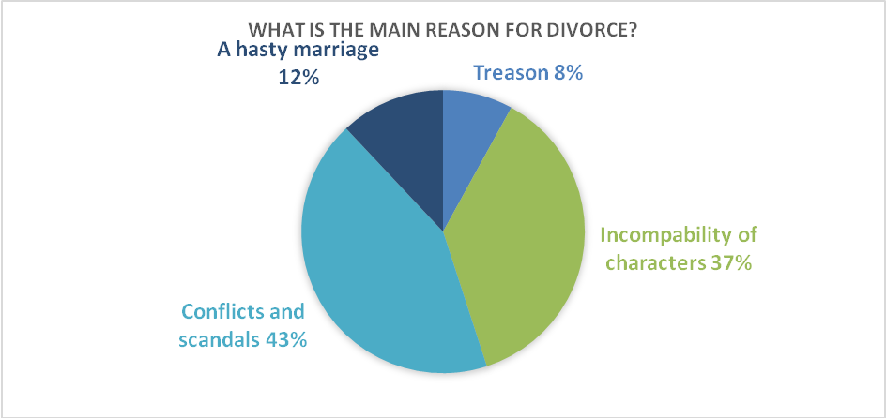

Graph 6

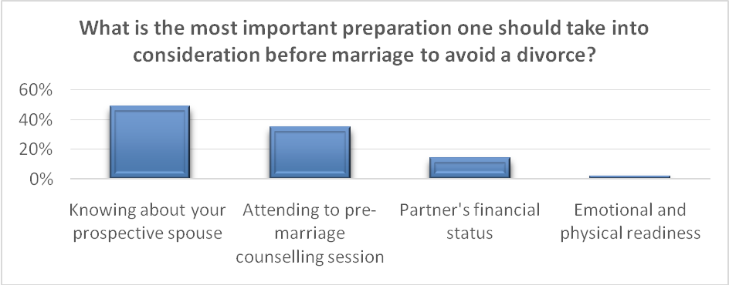

Questionnaire

What is your gender?

|  |  |
| --- | --- |
| Male | Female |
|  |  |

Are you married?

|  |  |  |
| --- | --- | --- |
| Yes | No | Divorced |
|  |  |  |

Do you know people who had married and recently divorced?

|  |  |
| --- | --- |
| Yes | No |
|  |  |

After what period of time people get divorced mostly often?

|  |  |  |  |
| --- | --- | --- | --- |
| After a month | After one year | After three years | After ten years |
|  |  |  |  |

What are the main reasons for divorce?

|  |  |  |  |  |
| --- | --- | --- | --- | --- |
| A hasty marriage | Treason | Conflicts and scandals | Incapability of characters | Others |
|  |  |  |  |  |

What is the most important preparation one should take into consideration before marriage to avoid a divorce?

|  |  |  |  |
| --- | --- | --- | --- |
| Knowing about your spouse | Attending to pre-marriage counseling session | Partner’s financial status | Emotional and physical readiness |
|  |  |  |  |